**Module 7**

**Assignment 1**

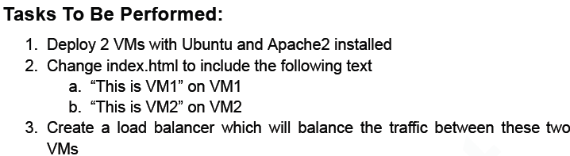

1. Create 2 VMs and Install Apache 2 in it : sudo apt install apache2 -y

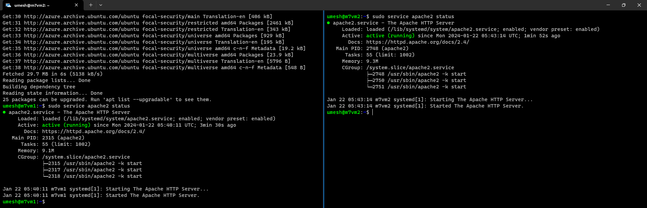

1. Once apache2 is installed, make sure port 80 is open and edit the index.html file inside /var/www/html/ and edit it as “This is VM1” and “This is VM2”



1. Create a Load Balancer for the two VMs.

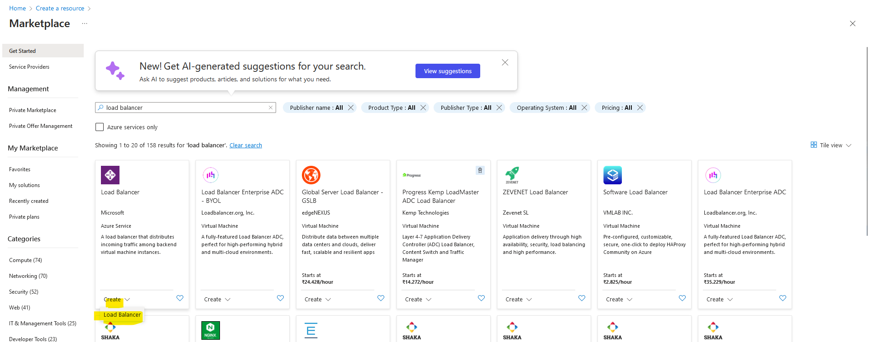

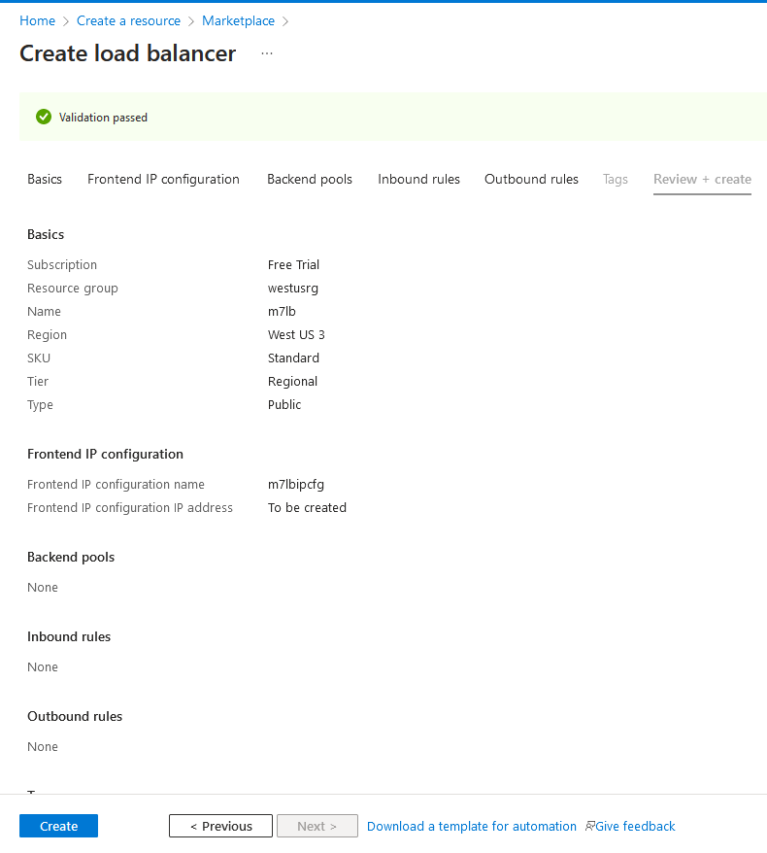

1. Go to the VM and add the created load balancing.

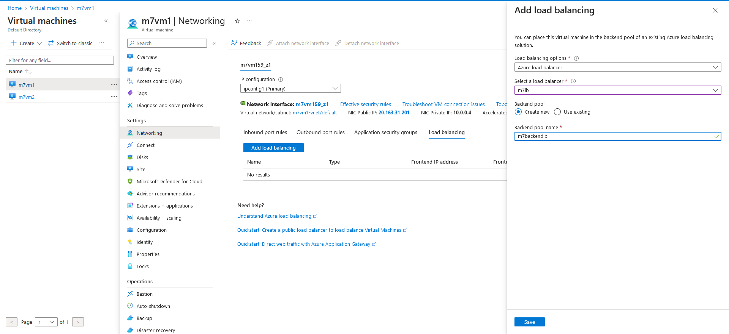

1. Once added, browse the Load Balancing via it’s public IP.

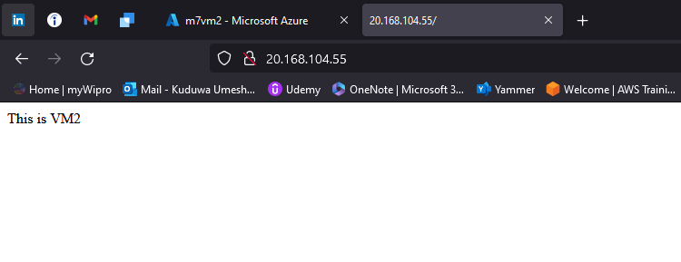

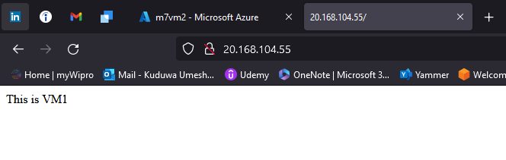

**Assignment 2**

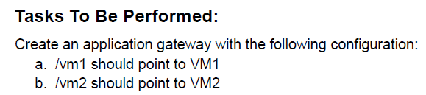

1. Create Backend Pools for VM1 and VM2
   1. In the Azure Portal, navigate to the Application Gateway resource.
   2. Under the "Settings" section, click on "Backend pools."
   3. Create two backend pools:
      1. VM1BackendPool: Add VM1 as a backend target.
      2. VM2BackendPool: Add VM2 as a backend target.
2. Create HTTP Settings
   1. Under the "Settings" section, click on "HTTP settings."
3. Create two HTTP settings:
   1. VM1HTTPSettings: Configure it to point to VM1BackendPool.
   2. VM2HTTPSettings: Configure it to point to VM2BackendPool.
4. Create Listener
   1. Under the "Listeners" section, click on "Add a listener."
5. Configure the listener:
   1. Frontend IP: Choose an existing or create a new one.
   2. Frontend port: Specify a port (e.g., 80).
   3. Protocol: HTTP
6. Create Rules for URL Path Routing
   1. Under the "Rules" section, click on "Add a rule."
7. Configure the rule:
   1. Rule name: Specify a name.
   2. Listener: Choose the listener created in Step 3.
   3. Backend target type: Choose "IP Address" and use the IP address of VM1 or VM2.
   4. HTTP settings: Choose the appropriate HTTP settings (VM1HTTPSettings or VM2HTTPSettings).
   5. Paths: Add a path map with the following configuration:
   6. /vm1/* -> VM1HTTPSettings
   7. /vm2/* -> VM2HTTPSettings
8. Review and Create
   1. Review your configuration settings for the Application Gateway.
   2. Click "Review + create."
9. After validation passes, click "Create" to deploy the Application Gateway.
10. Verify Configuration
    1. Once the deployment is complete, go to the Application Gateway resource in the Azure Portal.
    2. Obtain the public IP address associated with the Application Gateway.
11. Test the configuration by accessing the following URLs in a web browser:
    1. http://<ApplicationGatewayIP>/vm1 should point to VM1.
    2. http://<ApplicationGatewayIP>/vm2 should point to VM2.

**Assignment 3**

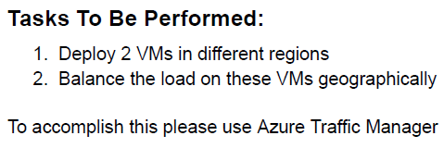

1. Create 2 VM’s : 1 in India and other in US.

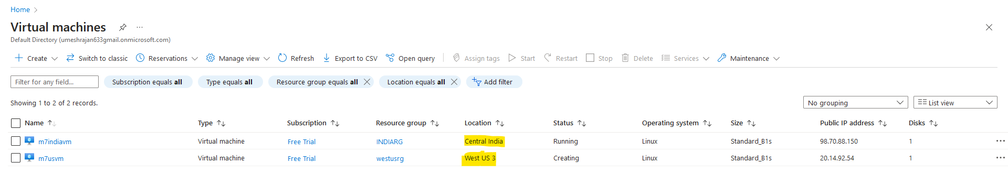

1. Search for Traffic Manager Profile and Create.

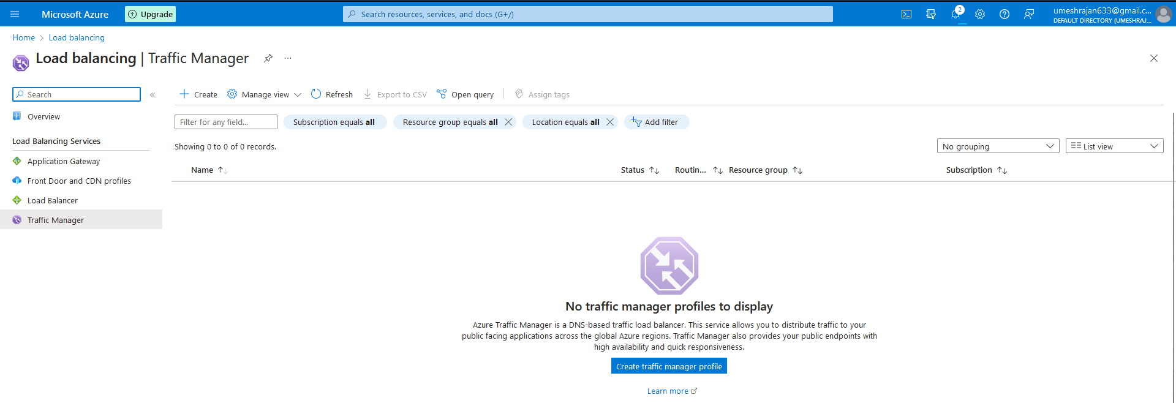

1. Once created, add 2 Endpoints.

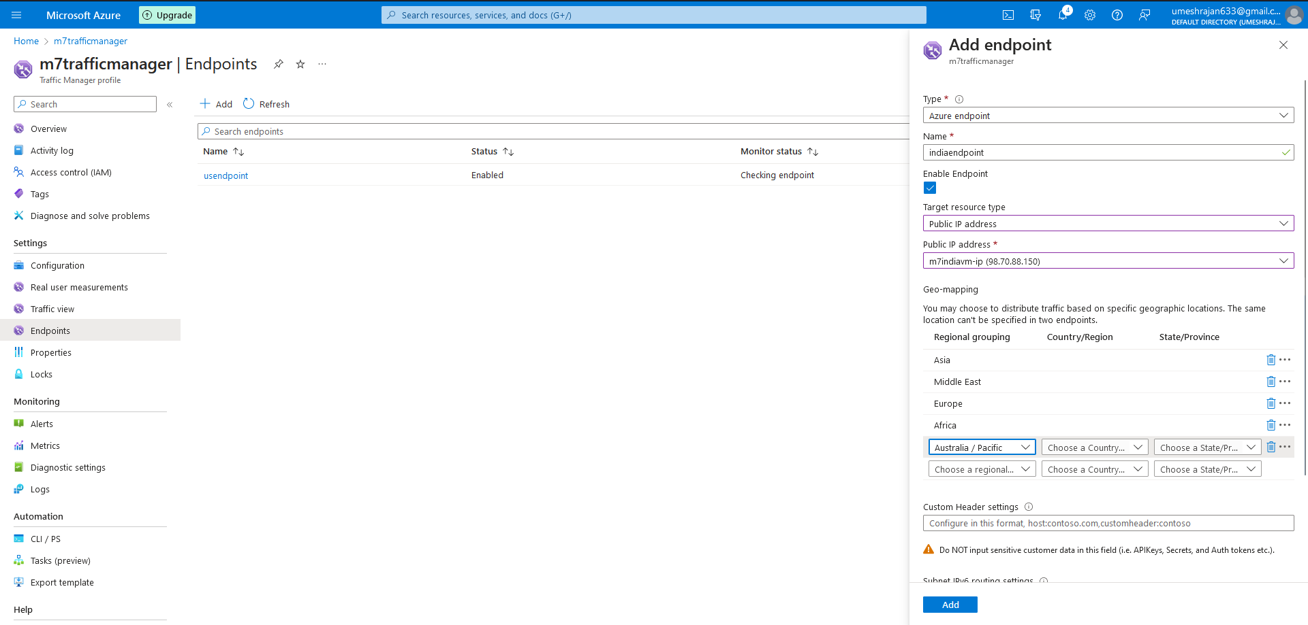

1. Browse the newly created Traffic Manager to check if it’s working.
   1. Connected to US via VPN.

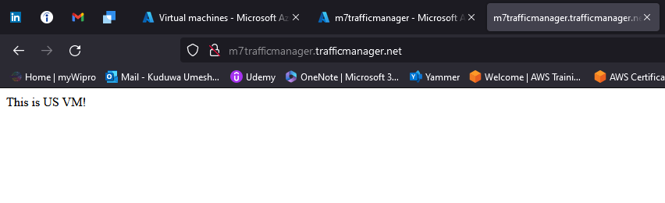

* 1. Connected via Direct Internet (India)

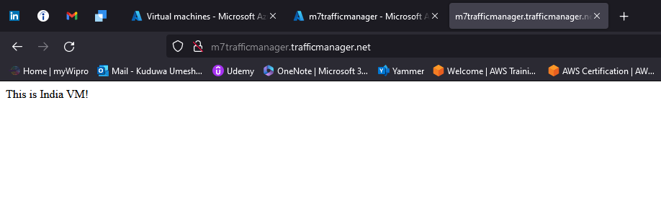

**Assignment 5**

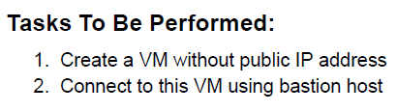

1. Create a new VM without any Public IP assigned to it.

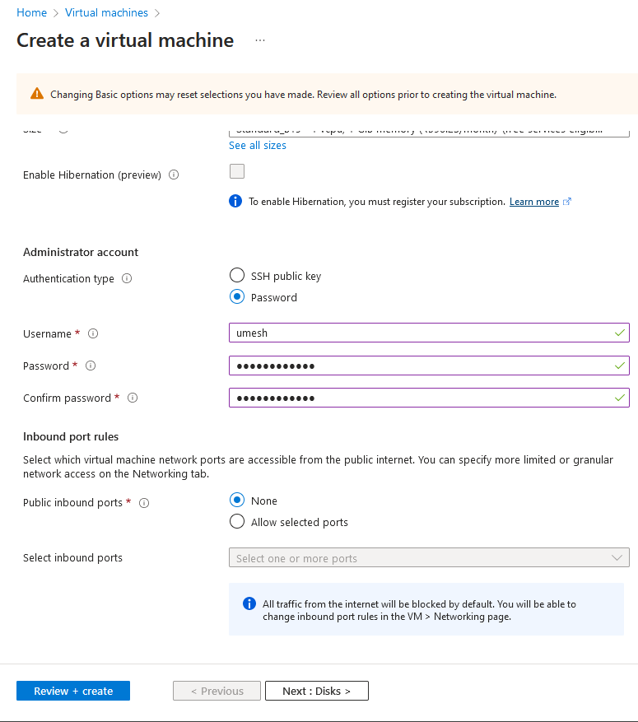

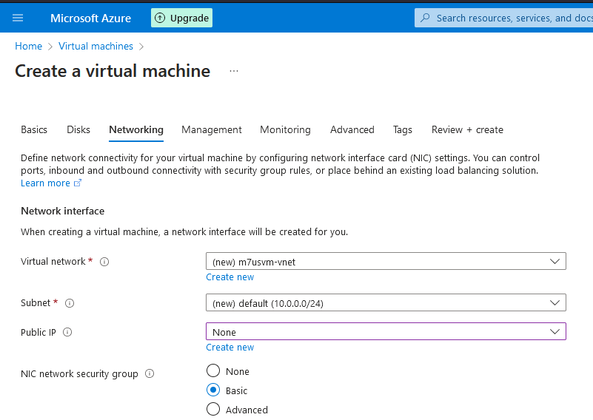

1. Go to the VM, and under Operations tab. Select Bastion.

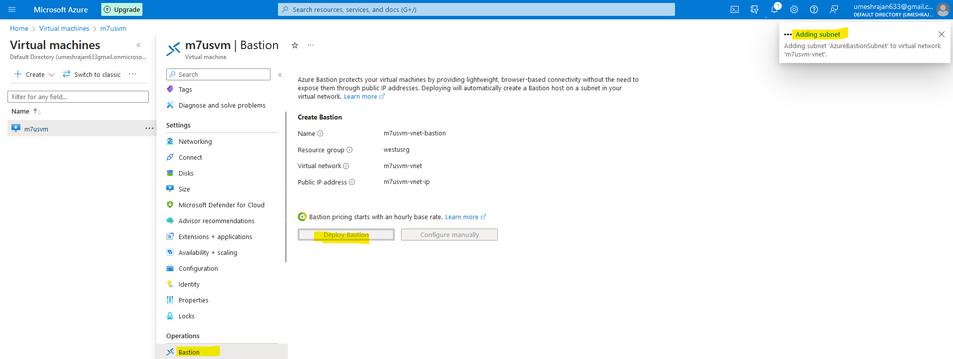

1. Give the credentials for the VM. You will be connected to the VM without the Private IP.

